PROJECT REPORT TEMPLATE

# INTRODUCTION

## Overview

My project is Educonnect Learning center I handle the project easily with my team members.

## Purpose

We use this to handle the accounts effortlessly.

## Problem Definition and thinking

## Empathy Map

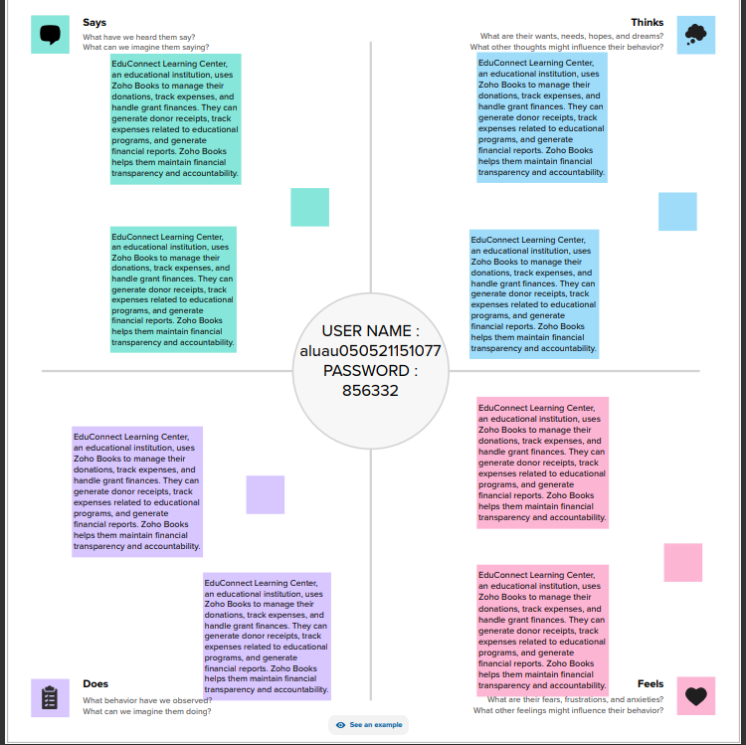

## Ideation and Brainstorming Map

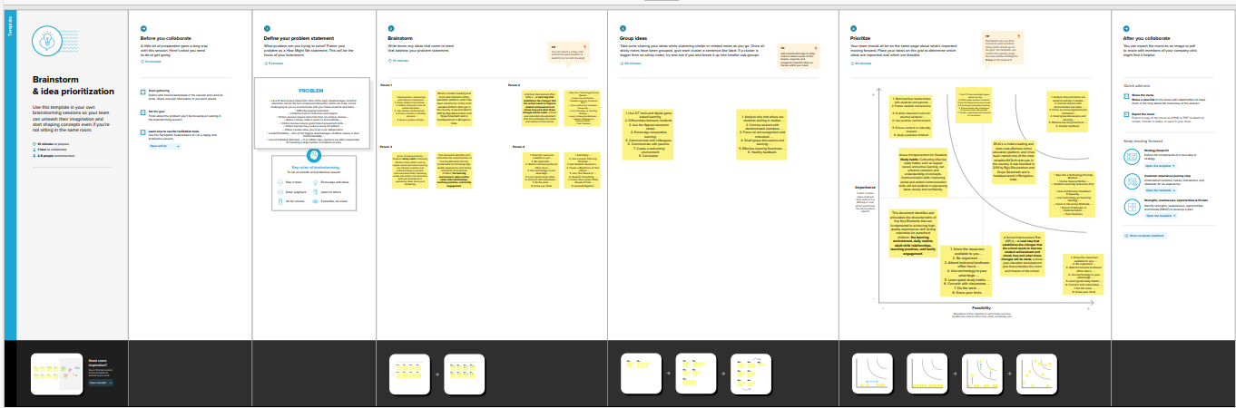

## Result

## 

## Advantages and Disadvantages

It is very useful to handle accounts.

## Conclusion

Its creates useful information

## Future scope

It is very useful to future